Date: 13.06.2025
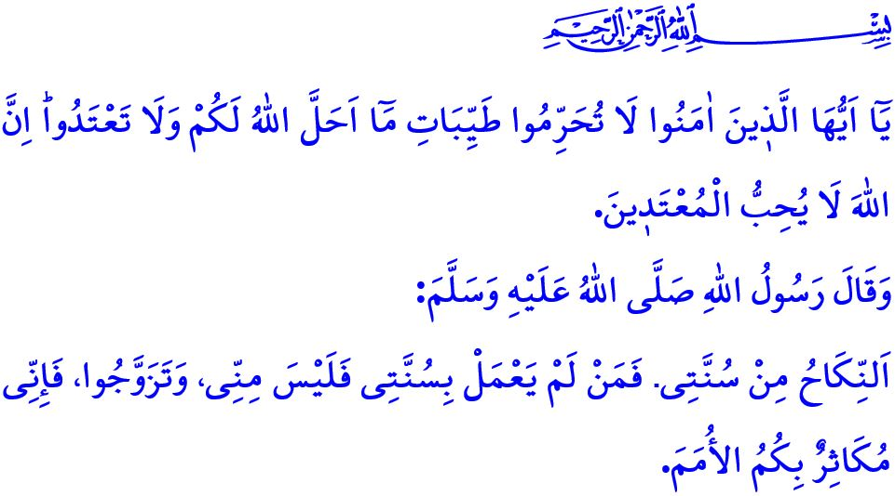
WEDDING ETIQUETTE
Honorable Muslims!
Marriage stands as one of the most significant days and milestones in a person’s life. Marriage is the sacred union of a man and a woman through a legitimate marriage contract, established in accordance with the command of Allah and the Sunnah of the Prophet (saw). Marriage is a strong shield that guards the spouses’ eyes from haram, preserves their chastity, and upholds their honor and dignity. It is the safeguard of a pure and healthy generation, and the foundation of a strong, resilient society. Allah the Almighty calls upon believers who remain distant from marriage to live a balanced and disciplined life, stating: “O believers! Do not forbid the good things which Allah has made lawful for you, and do not transgress. Indeed, Allah does not like transgressors.”
Dear Believers!
Ceremonies such as engagement, marriage contract (nikah), and wedding, which signify the announcement of marriage, are elegant means of sharing joy and happiness. They are rare opportunities to unite hearts, strengthen bonds of unity and solidarity, and deepen friendships. As with all aspects of life, our standard in engagement, marriage, and wedding ceremonies is our sublime religion, Islam. Our religion allows men and women to enjoy celebrations at wedding ceremonies so long as they remain within the bounds of what is lawful and observe privacy among themselves. However, a form of celebration that disregards privacy, neglects tasattur, involves the consumption of alcohol, includes armed celebrations that turn joy into sorrow, blasts loud music that disturbs others day and night, and endangers lives and property through reckless convoys has no place in our religion.
Esteemed Muslims!
Wedding ceremonies, which ought to be conducted with a simple ring, a heartfelt supplication, and a modest offering, have unfortunately turned into extravagant events marked by wastefulness and ostentation in our time. Everything that is done in excess, ranging from lavish halls to wasteful menus, from attire that does not comply with the principles of tasattur to gift-giving practices that resemble a competition of jewelry and are treated more like a debt than a gesture of goodwill, undermines the true spirit of marriage. The Messenger of Allah’s (saw) warning in this regard is quite clear: خَيْرُ النِّكَاحِ أَيْسَرُهُ “The best marriage is the simplest.” Therefore, the steps leading to marriage, such as the proposal, asking for the bride’s hand, the bethrotal, henna night, and dowry, should never become burdens too heavy for families and young people to bear. Events like “bridal baths,” “bachelor and bachelorette parties,” “gender reveals,” and “baby showers”, which have no place in our religion or culture and invite sins forbidden by Allah, should never be practiced. Circumcision of children, which our beloved Prophet (saw) regarded as a natural necessity, must never be stripped of its true purpose. Circumcision celebrations should never become occasions of vanity and pride, marked by extravagant outfits, excessive spending, and lengthy convoys.
Dear Believers!
Let us not forget that as marriages drift away from simplicity and turn into displays of ostentation, they become a heavy burden. This alienates young people from marriage or even discourages them from marrying altogether. When weddings are ruled by “What will the world say?” instead of “the sake of Allah”, discomfort replaces mercy, resentment takes the place of affection, and debt overshadows blessings. Expenses justified by customs and traditions, driven by the mindset of “Nothing should be missing!” plunge both families and young people into irreparable hardship, weighed down by debt and interest.
Dear Muslims!
It is the responsibility of both families, society and responsible persons and institutions to marry our young people in accordance with the command of our Almighty Lord, وَاَنْكِحُوا الْاَيَامٰى مِنْكُمْ “Marry off the ˹free˺ singles among you...” Therefore, in an era where the age of marriage is rising and birth rates are falling, it is our duty to encourage our young people to marry, to ease the path to marriage, and to offer them both material and moral support along the way. Our duty is to heed the divine warning, اِنَّ الْمُبَذِّر۪ينَ كَانُٓوا اِخْوَانَ الشَّيَاط۪ينِۜ “...Surely the wasteful are ˹like˺ brothers to the devils....”, and steer clear of excess and waste in all things, including our weddings . Our duty is to pay attention to the prophetic warning, مَنْ كَانَ يُؤْمِنُ بِاللَّهِ وَالْيَوْمِ الْآخِرِ فَلَا يَقْعُدَنَّ عَلَى مَائِدَةٍ يُدَارُ عَلَيْهَا بِالْخَمْرِ “Whoever believes in Allah and the Last Day must never sit at a table where alcohol is served.”, and ensure that no form of alcohol, the root of many evils, finds a place in our weddings . It is to never attend events where alcohol is served. Our duty is to adhere to the verse, وَلَا يَخَافُونَ لَوْمَةَ لَٓائِمٍۜ “…fearing no blame from anyone...”, and place Allah’s pleasure and the honor of His Messenger above all else. As in every aspect of our lives, we must be content with what is halal in our weddings and steadfastly avoid indulging in anything haram.

I would like to conclude this Friday’s khutbah with our Prophet’s (saw) following hadith: “Nikah is my sunnah. Whoever does not follow my sunnah is not from me. Marry and multiply, for on the Day of Resurrection I will boast of your numbers against other nations.”

Bukhari, Nikah, 3.
Ma’idah, 5/87.
Abu Dawud, Nikah, 30-31.
Bukhari, Libas, 63.
Nur, 24/32.
Isra, 17/27.
Ibn Hanbal, I, 20.
Ma’idah, 5/54.
Ibn Majah, Nikah, 1. General Directorate of Religious Services

